Media Compression and Distribution UG3

Tutorial: Revision – Modulation

Q1
Explain the processes of Amplitude Modulation and Frequency Modulation
How is the varying signal represented in the modulated carrier?

AM – The carrier wave is modulated by the signal; the amplitude of the carrier varies in accordance with the amplitude of the signal
FM – The carrier wave is modulated by the signal; the frequency of the carrier varies in accordance with the amplitude of the signal. A higher amplitude of the signal results in a higher frequency of the carrier

Sketch the spectrum of an AM signal

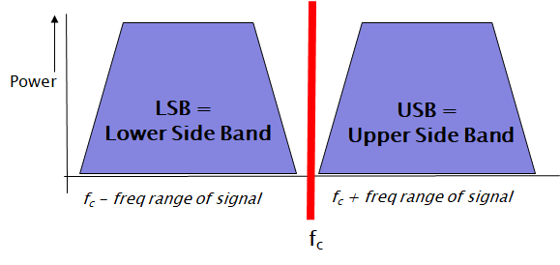

Explain "phase modulation" (educated guess)
(what is "phase"?)

For phase modulation the phase of the carrier varies in accordance with the signal.
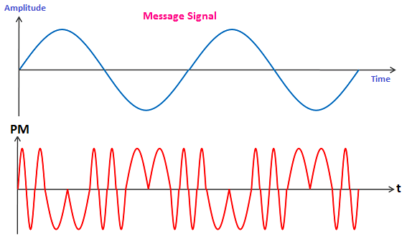

Q2
Explain interlacing vs progressive scan
What is the advantage and disadvantage of interlacing?

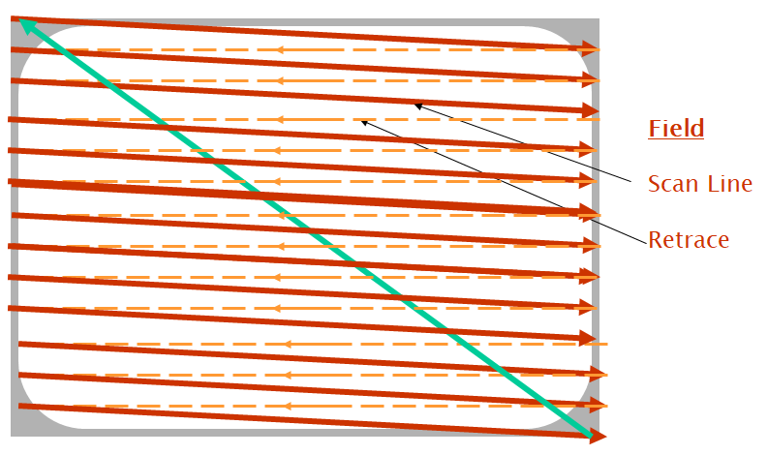

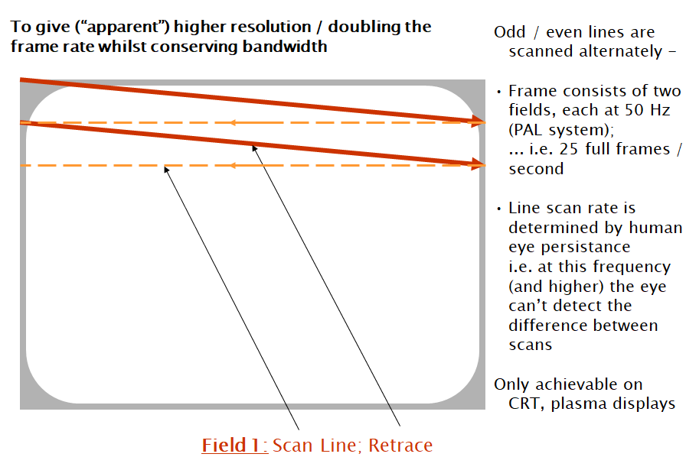

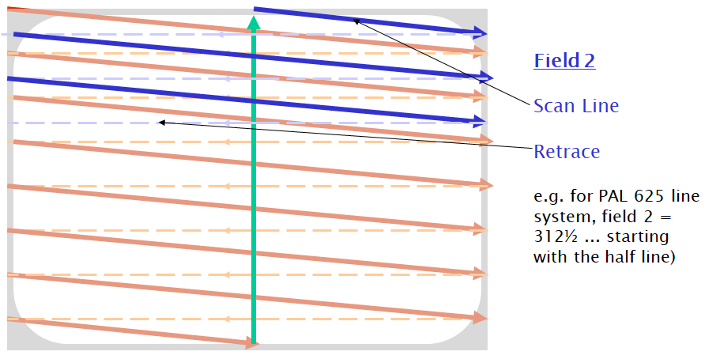

Interlacing allows an apparent higher resolution / doubling the frame rate whilst conserving bandwidth
However, because the two fields of the scan are half a frame apart, there is a time delay within the frame the requires buffering for reception, and also gives “tearing” effects during playback.

Q3
Where are PAL and NTSC systems used (predominantly)

PAL – predominantly in European and associated markets (i.e traditional trading areas)
NTSC – North America and associated markets (Japan, etc)
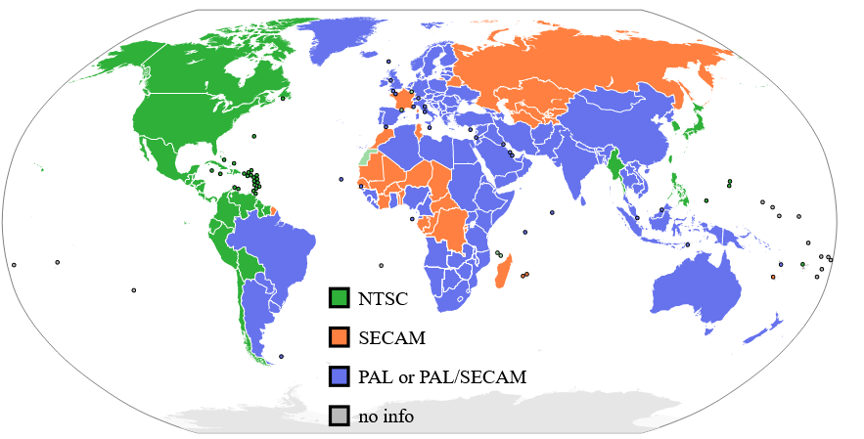

Sketch a TV broadcast spectrum, identifying the colour and audio aspects of the signal spectrum

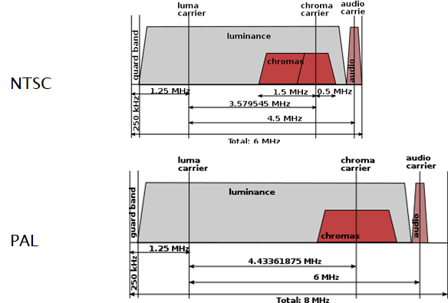

What is the frame rate of (i) PAL systems; (ii) NTSC systems. Why are they different?
Any other differences between the systems?

Frame rates are/were determined by national power supply frequencies
So 60Hz in USA allows for 30fps and 60fps; although the transition to colour required a review of the frequency spacings in the spectrum and resulted in the frame rate being changed to 29.97 and 59.94fps

PAL utilises an alternating phase between colour signals on alternate lines to overcome phase differences which may arise during the transmission (hence the name PAL – phase alternate line). NTSC doesn’t have the phase adjustments and so may result in phase issues in transmission, thereby giving a slight colour cast in the picture, which required a “tint” control on consumer TV sets. PAL also has a wider bandwidth at 7MHz per channel (plus a 1MHz spacing between channels). NTSC has 6MHz channels (plus a 1MHz spacing between channels).

Q4
Describe the process of
(i) TDM (time division multiplexing)
(ii) FDM (frequency division multiplexing); explain the function of a subcarrier in FDM
(iii) Statistical Multiplexing,

What are the operational issues and decisions taken by a network operator who is providing a statistical multiplexing playout?

TDM – data is allocated its own time slots in a bit stream, so a number of data inputs (typically 30) make up a number of timeslots (i.e. 30) in a frame of time-multiplexed channels (TDM). Each slot has its predetermined bandwidth, whether data is to be transmitted or not. This is wasteful in network resources, but does guarantee a fixed slot in the network, so no variable buffering is required.
FDM allocates a frequency space for each channel in a multiplex.

To allow for better network resource utilisatio, statistical multiplexing packetizes data and allocates them to an outgoing port from a router when space is available; if a space isn’t available, the packet needs to be queued; this results in an unpredictable variable buffer and ongoing transmission of packets. The packets are allocated onto a bit stream, the rate of which is calculated to support the traffic required (typically at busy periods); even so, the stream may become full and so there is a probability of data having to queue during these congested periods.

It also means that in packetized data, each packet is labelled, addressed and processed individually which required processing and buffering resources in the network nodes. TDM doesn’t require this since the data is transmitted in the pre-determined slots.

